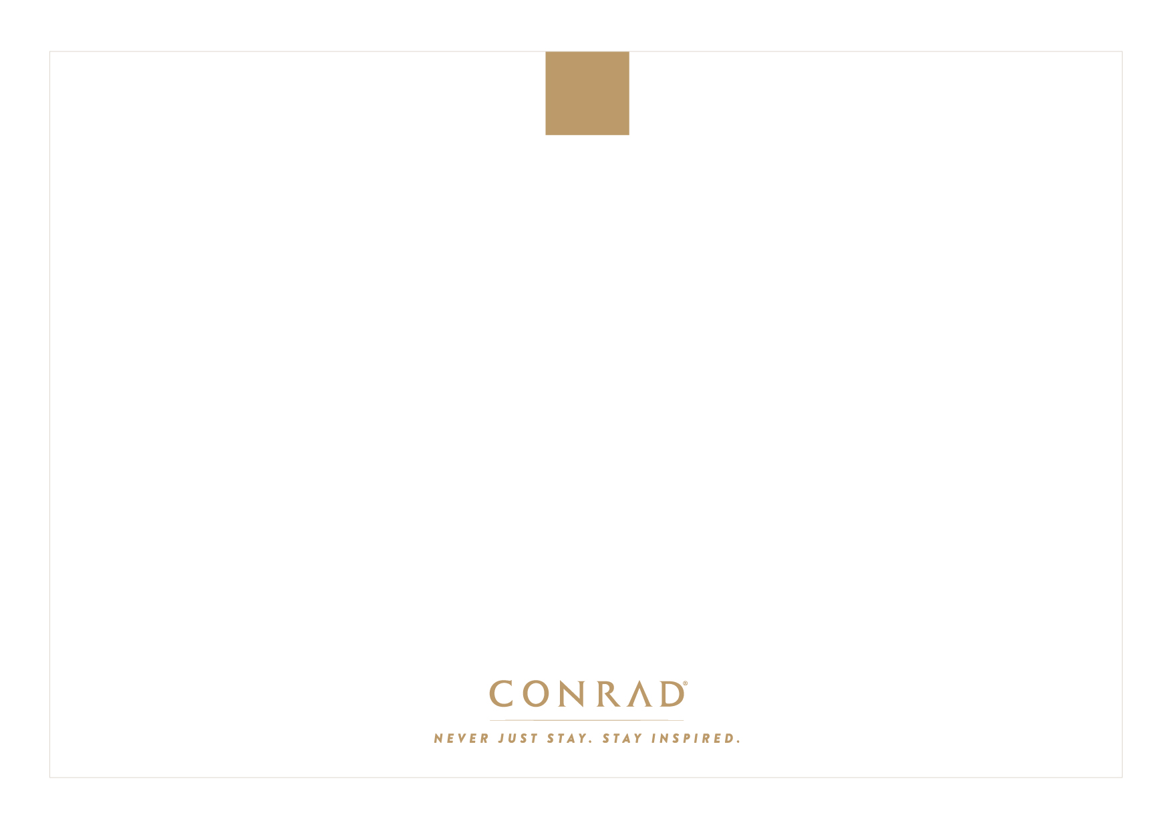­

**Type Name here**

HIGH FIVE

- Type Sender’s Name Here

Type your personal message here. All content is customizable, including language.

You can use up to five lines in this space to write your message.